Creating projects from Word
into the Berlin template
Documentation Control

All rights are strictly reserved. This document may not be reproduced in whole or in part without the express written permission of NetexKnowledge Factory.

Document author | Version | Release date | Implemented changes
Netex | 1.0 | 10/06/2020

It is possible to import the contents from Word into the Berlin template in contentCloud.
Make sure to apply specific tags that will allow the import to be as close as possible to the final assembly.
Paste this element and select the desired tag inside it:

[:mainTitle]

It is not necessary to close the tags. These are automatically closed when you add a tag next.
Remember: the available tags must follow a hierarchy. Thus, to create a screen, you must first add the page tag. Likewise, to add a text, the screen tag must exist first.

CONTENT TAGS
Tag to create...
Unit title |  |  | [:mainTitle]
Cover page |  |  | [:pageContent:cover]
 | Section |  | [:blocks]
Content page |  |  | [:pageContent]
 | Screen |  | [:blocks]
 |  | Text | [:text]
 |  | Quotation | [:cite]
 |  | Accordion | [:accordion]
 |  | Tab menu | [:tabs]
 |  | Standard-type panel | [:panel:standard]
 |  | Tilted to the right panel | [:panel:right]
 |  | Tilted to the left panel | [:panel:left]

QUIZ TAGS
There are currently four types of questions activities available for quiz creation.
Remember: to create a quiz, you must first add the "quiz" tag and then add the questions. If the questions are created without the "quiz" tag, the import will be incorrect.
Tag to create…
Quiz |  | [:quiz]
 | Single choice | [:qSingleChoiceActivity]
 | Multiple-choice | [:qMultipleChoiceActivity]
 | True/False | [:qTrueFalseActivity]
 | Tap-tap | [:qTapTapActivity]

WORD IMPORT into contentCloud:
Once all the content is tagged, import the Word from the contentCloud instance.
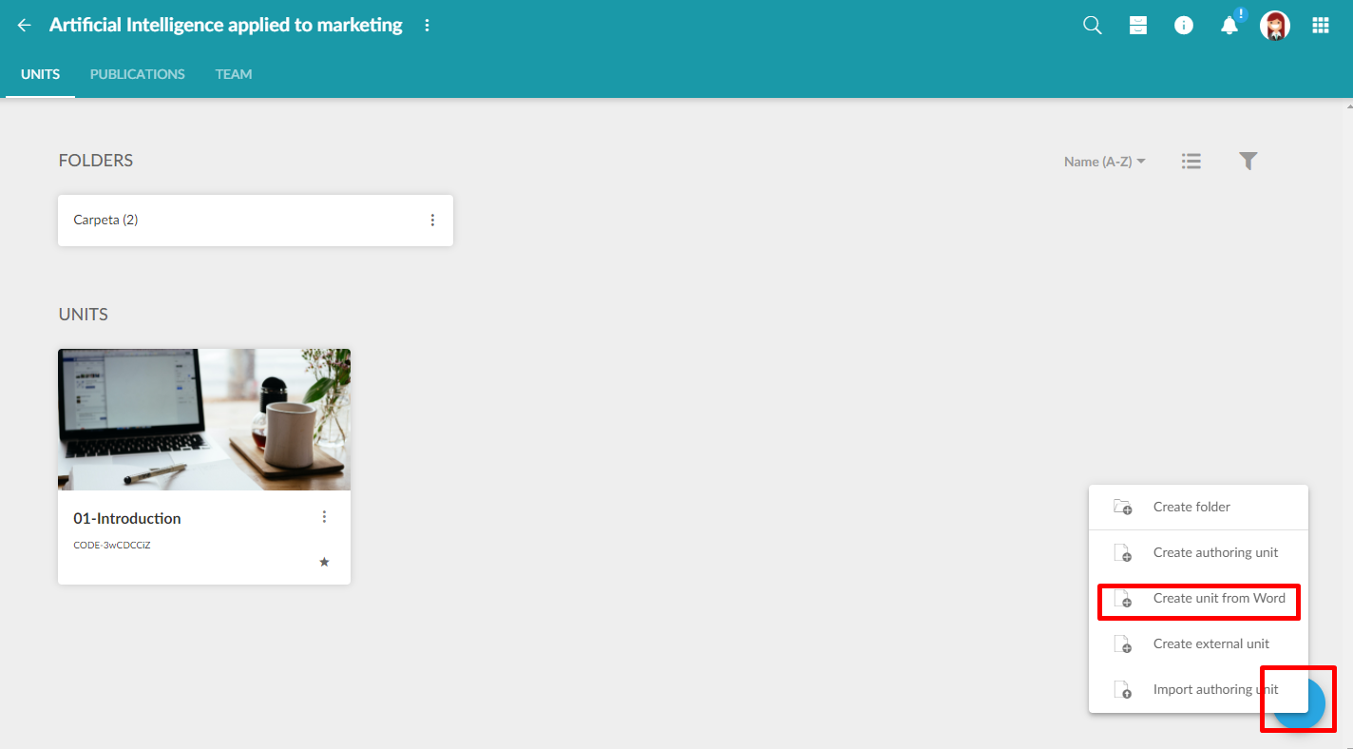
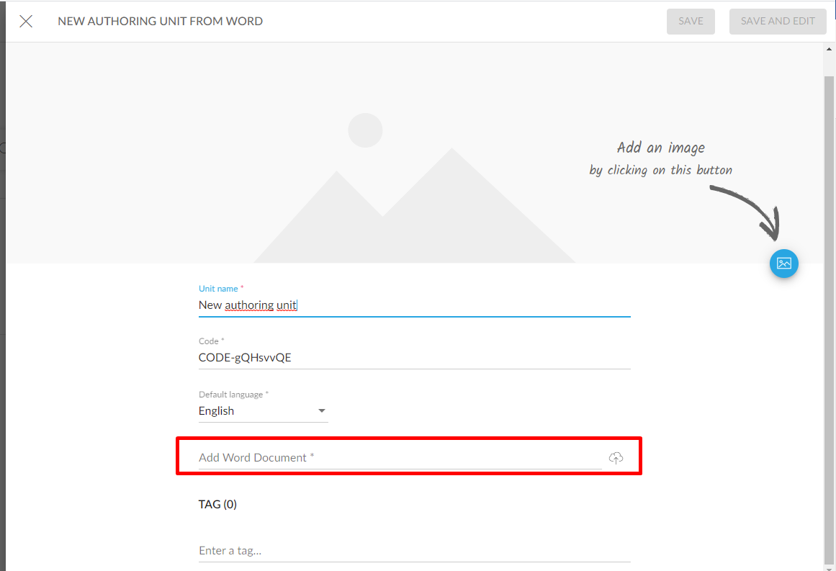
After the import, we can modify the contents as we wish, applying the necessary graphic settings (screen width, background, etc.).

USE EXAMPLES of applied tags:
[:mainTitle]
Course title

[:pageContent:cover]
Cover title

[:blocks]
Block title

[:text]
It is possible to add a text within the cover block (e.g., to describe the unit's didactic objectives).

[:pageContent]
Section 1

[:blocks]
Subsection 1.1.

[:text]
Text in italics and bold. Italics, bold, and underlined text.
Text with External link.
Coloured text and highlighted text are not supported.
Numbered lists are supported:
- A
- B
- C
Bullet lists are supported:
- List 1
- List 2
It also supports tables, for example:
 | Madrid | Vienna | Paris
The Eifel Tower is in... | NO | NO | YES
The Puerta de Alcalá is in... | YES | NO | NO

Mathematical formulas:
Example of vector $\left(\begin{aligned}1 \\ 2 \\ 3\end{aligned}\right)$
Example of numbered equation $\left(\begin{aligned}a \\ b\end{aligned}\right)=\left(\begin{matrix}α & β \\ γ & δ\end{matrix}\right)\left(\begin{aligned}s \\ t\end{aligned}\right)+\left(\begin{aligned}u \\ v\end{aligned}\right)\left(1.1\right)$

Example of matrix $\left(\begin{matrix}1 & 2 & 3 \\ 4 & 5 & 6\end{matrix}\right)$

Example of equation $\lim_{}{f}\left(x\right)=\int_{-π}^{+π}{\left(\frac{g\left(t\right)}{2tπ^{2}}dt\right)}$

[:cite]
Quotation text
Author of the quoted text

[:panel:standard]
Panel title
Panel text. This assembly can also be used for the tilted to the right or to the left panel.

[:accordion]
Accordion Header 1
With multi-line
- Item 1
- Item 2
- Item 3
Accordion Header 2
Table in accordion
Cell 1.2 | Cell 1.2
Cell 2.1 | Cell 2.2

[:tabs]
Tab 1 Header | Tab 2 Header | Tab 3 Header | Tab 4 Header
Table in tabs  Header Header Header  body body body | Tab text 2 | Tab text 3 | Tab text 4

[:quiz]
Quiz statement

[:qSingleChoiceActivity]
Question statement
Option 1 statement | true
Option 2 statement | false
Option 3 statement | false
Positive feedback example | positive
Negative feedback example | negative

[:qMultipleChoiceActivity]
Question statement
Option 1 statement | true
Option 2 statement | true
Option 3 statement | false
Positive feedback example | positive
Negative feedback example | negative

[:qTrueFalseActivity]
Question statement
Option 1 statement | true
Option 2 statement | true
Option 3 statement | false

[:qTapTapActivity]
Question statement
Origin 1 | Destination 1
Origin 2 | Destination 2
Origin 3 | Destination 3

