Creating projects from Word
into the Tokyo template

Documentation Control

All rights are strictly reserved. This document may not be reproduced in whole or in part without the express written permission of NetexKnowledge Factory.
Document author | Version | Release date | File name
Yrma Díez | 1.0 | 20/11/2018 | Netex_Word_Plantilla_automatización.docx
Yrma Díez / María José Fdez | 2.0 | 25/01/2018 | Netex_Word_Plantilla_automatización_v2.docx

It is possible to import the contents from Word into the Tokyo template in Maker.
Make sure to apply specific tags that will allow the import to be as close as possible to the final assembly.
It is not necessary to close the tags. These are automatically closed when you add a tag next.
Paste this element and select the desired tag inside it:

[:mainTitle]

Remember: the available tags must follow a hierarchy. Thus, to create a screen, you must first add the page tag. Likewise, to add a text, the screen tag must exist first.

CONTENT TAGS
Tag to create...
Unit title |  |  |  | [:mainTitle]
Page |  |  |  | [:pageContent]
 | Screen |  | [:screen]
 |  | Text | [:text]
 |  | Quotation | [:cite]
 |  | Highlighted | [:panel]
 |  | Accordion | [:accordion]
 |  | Tab menu | [:tabs]
 |  | Image | [:image]

QUIZ TAGS
There are currently four types of questions activities available for quiz creation.
Remember: to create a quiz, you must first add the "quiz" tag and then add the questions. If the questions are created without the "quiz" tag, the import will be incorrect.
Tag to create...
Quiz |  | [:quiz]
 | Single choice | [:qSingleChoiceActivity]
 | Multiple-choice | [:qMultipleChoiceActivity]
 | True/False | [:qTrueFalseActivity]
 | Tap-tap | [:qTapTapActivity]

WORD IMPORT into Maker:
Once all the content is tagged, import the Word from the contentCloud instance.
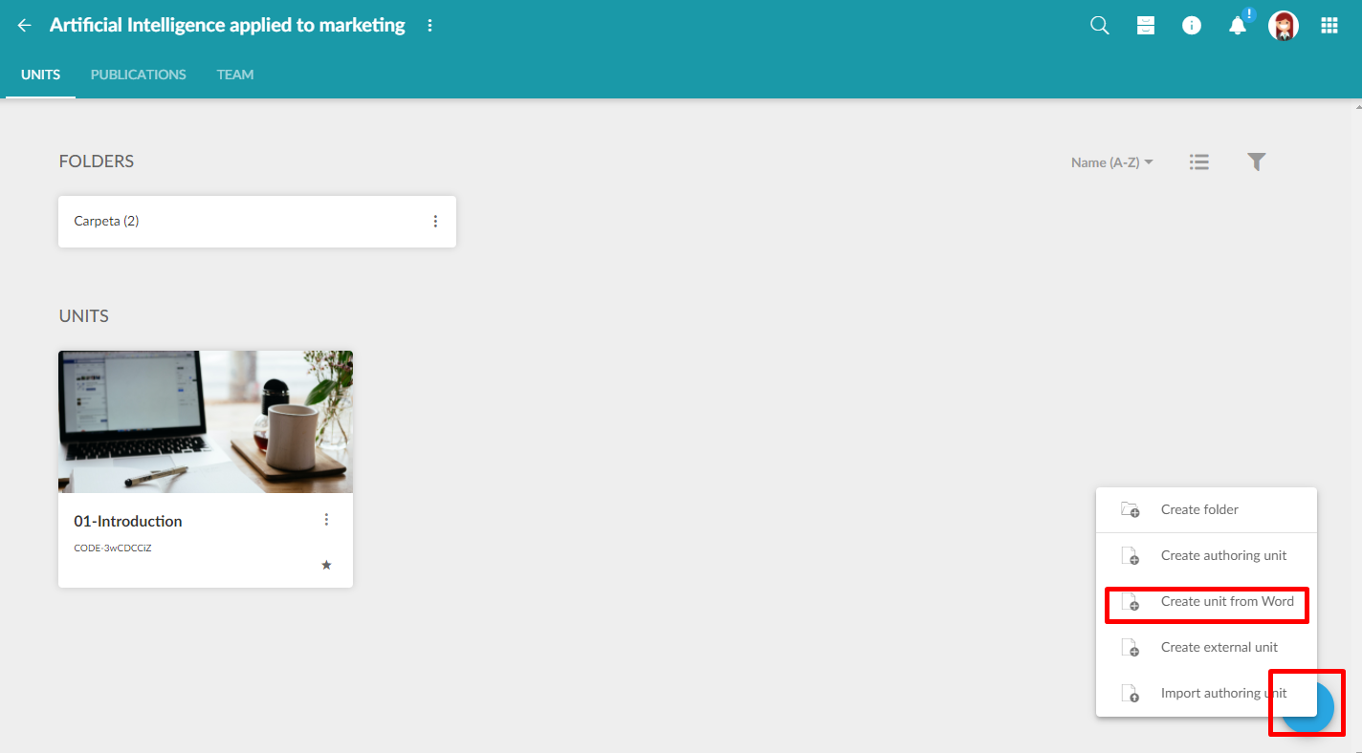
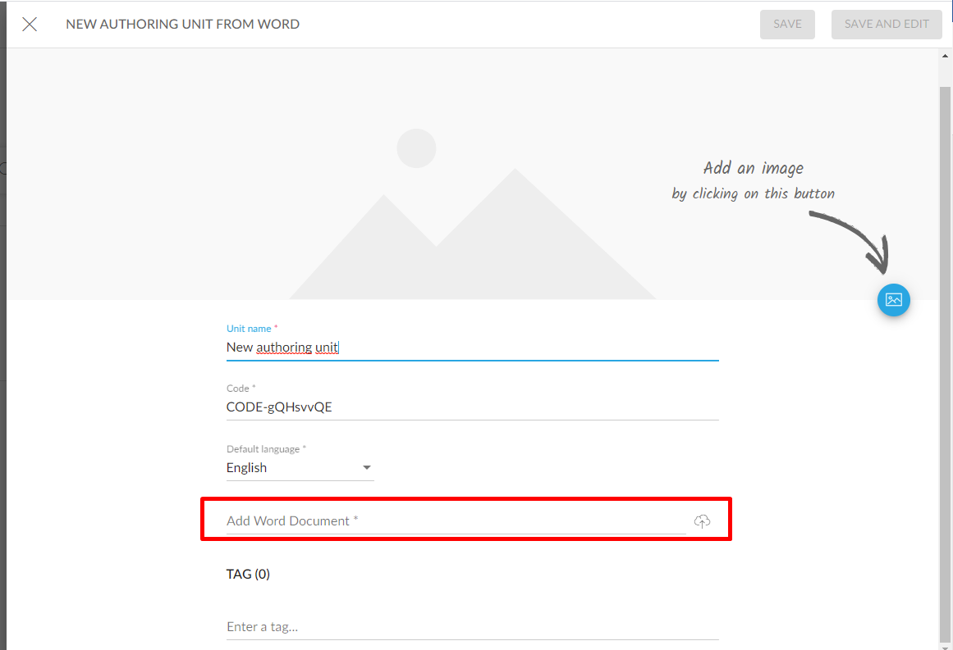
After the import, we can modify the contents as we wish, applying the necessary graphic settings (screen width, background, etc.).

USE EXAMPLES of applied tags:
[:mainTitle]
Course title

[:pageContent]
Section 1

[:screen]
Subsection 1.1.

[:text]
Text in italics and bold. Italics, bold, and underlined text.
Text with External link.
Coloured text and highlighted text are not supported.
Numbered lists are supported:
- A
- B
- C
Bullet lists are supported:
- List 1
- List 2
It also supports tables, for example:
 | Madrid | Vienna | Paris
The Eifel Tower is in... | NO | NO | YES
The Puerta de Alcalá is in... | YES | NO | NO

[:cite]
Quotation text
Author of the quoted text

[:panel]
Standard panel Title
Standard panel Text

[:panel]
Doubleheader panel Header 1
Doubleheader panel Header 2
Doubleheader panel Text1

[:accordion]
Accordion Header 1
With multi-line
- Item 1
- Item 2
- Item 3
Accordion Header 2
Table in accordion
Cell 1.2 | Cell 1.2
Cell 2.1 | Cell 2.2

[:tabs]
Tab 1 Header | Tab 2 Header | Tab 3 Header | Tab 4 Header
Table in tabs  Header Header Header  body body body | Tab text 2 | Tab text 3 | Tab text 4

[:image]
Images can be added after the tag only. It is also possible to add the following additional data table, either the whole data or part of the data.
title | Image title
filename | landscape
caption | Caption text.
credits | Source: author name
creditstype | Choose one of these two options:  negative  positive
creditsposition | Choose one of these four options:  top-left  top-right  bottom-left  bottom-right
instruction | Instruction text if necessary
alt | Alt text
width | Indicate one of these possible widths:  Auto  100%  75%  50%  33%
float | Choose one of these three options:  none  right  left

[:quiz]
Quiz statement

[:qSingleChoiceActivity]
Question statement
Option 1 statement | true
Option 2 statement | false
Option 3 statement | false
Positive feedback example | positive
Negative feedback example | negative

[:qMultipleChoiceActivity]
Question statement
Option 1 statement | true
Option 2 statement | true
Option 3 statement | false
Positive feedback example | positive
Negative feedback example | negative

[:qTrueFalseActivity]
Question statement
Option 1 statement | true
Option 2 statement | true
Option 3 statement | false

[:qTapTapActivity]
Question statement
Origin 1 | Destination 1
Origin 2 | Destination 2
Origin 3 | Destination 3

