Create units importing from Word
Assembly and Activities in Tokyo template
Documentation control

All rights are strictly reserved. No part or all of this document may be reproduced without the written consent of NetexKnowledge Factory.
Author of the document | Version | Date | File name
Yrma Díez | 1.0 | 20/11/2018 | Netex_Word_importing_instructions_v1.docx
Yrma Díez / María José Fdez | 2.0 | 25/01/2018 | Netex_Word_importing_instructions_v2.docx

In Maker we can import the contents from Word in the Tokyo template, applying certain labels that will allow the import to be as close to the final assembly as possible. It is not necessary to mark the closing of the labels, these are already assembled automatically with what we label after.
Paste this label in the Word document and select the desired label inside:

[:mainTitle]

Remember: there are certain labels that must follow a hierarchy. So, to create a screen, you must first add the page label. And to add a text, the screen label must first exist.

LABELS FOR CONTENTS
Label to create….
Unit title |  |  |  | [:mainTitle]
Page |  |  |  | [:pageContent]
 | Screen |  | [:screen]
 |  | Text | [:text]
 |  | Quote | [:cite]
 |  | Highlight | [:panel]
 |  | Accordion | [:accordion]
 |  | Tabs group | [:tabs]

LABELS FOR QUESTIONNARIES
We have 4 types of activities that can be imported.
Remember: to create a questionnaire you must first incorporate the "quiz" tag and then add the questions. If the questions are created without the "quiz" label, the import will be wrong.
Label to créate…
Questionnarie |  | [:quiz]
 | Simple choice | [:qSingleChoiceActivity]
 | Multiple choice | [:qMultipleChoiceActivity]
 | True/False | [:qTrueFalseActivity]
 | Tap-tap (arrows) | [:qTapTapActivity]

IMPORTATION PROCESS:
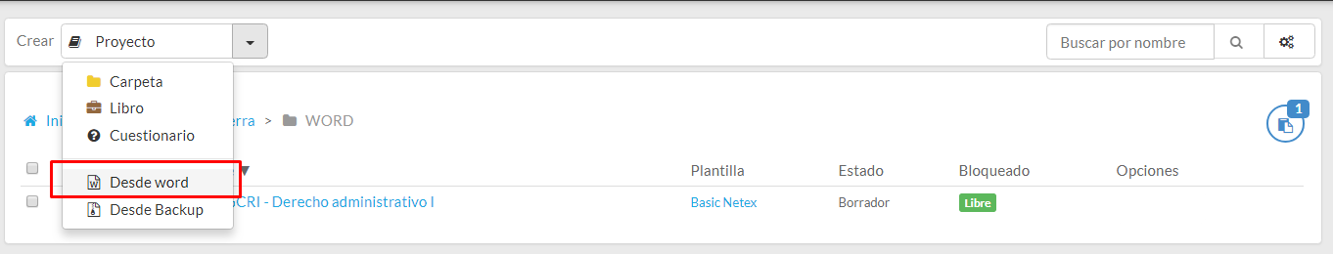
Once the document is labeled, we go to Maker and import the Word document After the import we can adjust the contents as we wish, having already the text with the italics and bold applied.

EXAMPLES OF USE of applied labels::
[:mainTitle]
Name of the unit

[:pageContent]
Section 1

[:screen]
Subsection 1.1.

[:text]
Text with italics, text with bold and underline is supported
Text with external link is supported.
Color in text or highlighted text is NOT supported.
Numbered lists are allowed:
- A
- B
- C
And bullet lists:
- Lista 1
- Lista 2
The tables are also allowed:
 | Rome | Vienna | Paris
Eifel tower is in… | NO | NO | SÌ
The Coliseum is in… | SÍ | NO | NO

[:cite]
Text of the quote
Author of the quote

[:panel]
Highlight title
Highlight content

[:panel]
Highlight title 1
Highlight title 2
Highlight content

[:accordion]
Title of accordion 1
- Item 1
- Item 2
- Item 3
Title of accordion 2
Content of accordion 2
Celda 1.2 | Celda 1.2
Celda 2.1 | Celda 2.2

[:tabs]
Title of tab 1 | Title of tab 2 | Title of tab 3 | Title of tab 4
Content of tab 1  header header header  body body body | Content of tab 2 | Content of tab 3 | Content of tab 4

[:quiz]
Title of the questionnarie

[:qSingleChoiceActivity]
Statement/Wording of the question
opcion 1 | true
opcion 2 | false
opcion 3 | false
Feedback positive example | positive
Feedback negative example | negative

[:qMultipleChoiceActivity]
Statement/Wording of the question
Enunciado opción 1 | true
Enunciado opción 2 | true
Enunciado opción 3 | false
Feedback positive example | positive
Feedback negative example | negative

[:qTrueFalseActivity]
Statement/Wording of the question
Text of opcion 1. | true
Text of opcion 2. | true
Text of opcion 3. | false

[:qTapTapActivity]
Statement/Wording of the question
Origin 1. | Target 1.
Origin 2. | Target 2.
Origin 3. | Target 3.

